Computer Networks
2nd Year, 1st Semester
2020

Tutorial 1

- ABC Company just purchased three new routers to start their company network. Which items are needed to establish a terminal session between a PC and the router for the initial configuration?
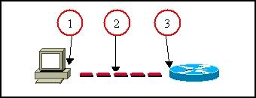

- State the methods to log to a router.

- Explain the main modes found in the process of configuring the router.

- State the two ways to retrieve previously used commands.

- How do you configure passwords for privilege mode?
Which password takes precedence?

- What are the functions of the RAM?

- Which keystrokes can be used to return to the privileged mode from the interface configuration mode?

- Which router component holds the configuration file when power is lost?

- How do you view the current configuration of the router?

- State the method of making a permanent copy of the configurations.

